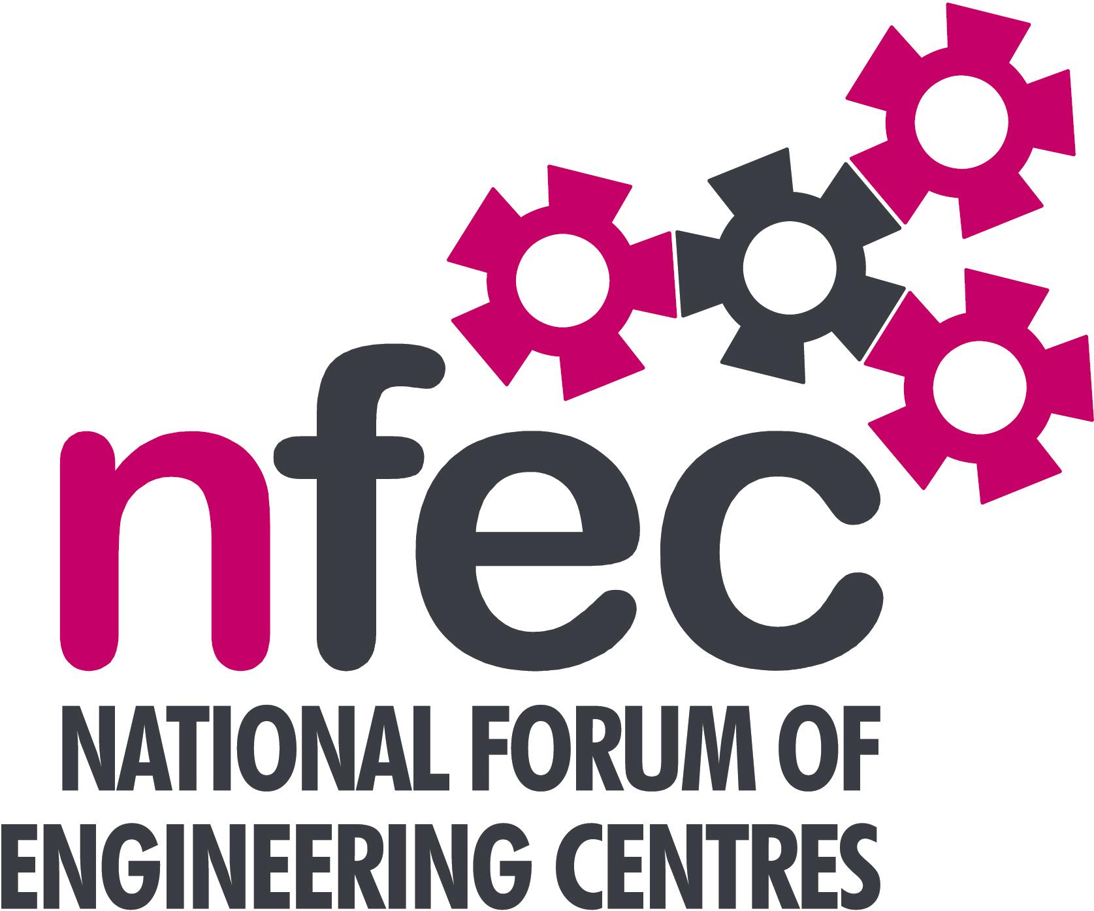
NFEC Autumn 2017 Regional Seminar
London and the South East
Host: Harlow College

Friday 3rd November 2017, 10.15am – 14.45 (Coffee from 10.00am)
Venue: Harlow College, Velizy Ave, Harlow CM20 3EZ
Telephone Number: 01279 868000

Programme

- Welcome and Introduction to the Seminar | Tom Stokes (NFEC London and SE Regional Coordinator and Harlow College) | 10.15
- Current matters of concern relating to quality, content, structure, management and delivery of programmes of training and education in Engineering (not included on Agenda) - an opportunity for open discussion with a focus to distill key issues and plans for addressing them.  - Demonstration by OneFile of software and an app which can be used on and offline to record training as essentially an eportfolio.  - Update on a T levels project which Harlow College have been involved with. This will include questions and discussions.  - Qualifications and Awarding Bodies – Current developments and general issues.  Lunch and Demonstrations by Exhibitors  Tour of facilities  - Plenary session – Issues to note and agreed actions for NFEC  Date, Place and Topics for next Seminar  Close  Entry is free to this seminar for members or to non-members present for a first attendance.There will be a charge for non members after this. A light buffet lunch will be provided and you will be able to see/discuss demonstrations of the latest available equipment and facilities for the delivery of learning in Engineering. | All Delegates/Tom Stokes  Nezihe Saffet, Onefile  Karen Spencer, Principal, Harlow College  Pearson - Chris Turner  C&G - Scott Wilkins  OCR – Martin Webber  All Delegates/Tom Stokes  All Delegates/Tom Stokes  To book your place: Email: admin@nfec.org.uk  Phone: 07759 901229 | 10.20  10.45  11.00  11.45  13.45

